
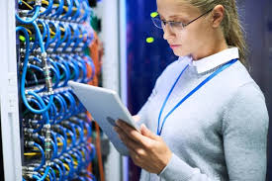
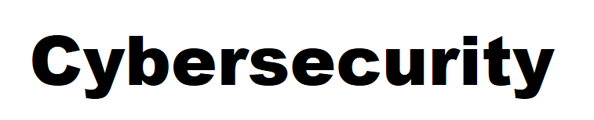
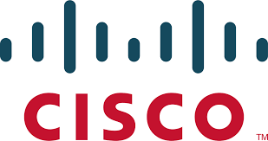

Palo Alto PA-220 Factory Reset Procedure
Joshua Widjaja
P5 Advanced Cisco Cybersecurity
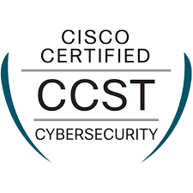
Mr. Mason

Purpose:
The purpose of this lab was to gain experience in the configuration of our PA 220 Palo Alto Firewall within a SOHO (Small Office Home Office) network infrastructure. Our task was to configure network policies, establish internet connectivity, and implement security policies all within the GUI (Graphical User Interface) of the PA 220 Firewall. Experience within the GUI for specifically PA 220 Firewalls gave us important skills needed to implement cybersecurity concepts into smaller network environments.

Background Information:

What is a Firewall? | - A firewall monitors and controls the incoming and outgoing network traffic.  - Essentially, it’s a wall protecting an internal network from an external network.  - As a network engineer you can choose which traffic comes in and the level of authorization needed to gain certain access.  - Through the use of network segmentation (dividing the network) on the firewall, you can control what parts of each network can reach one another.  - Based on the security policies configured on the firewall, your network can choose whether to allow or block certain incoming traffic.  - Firewalls are key to network security, as it can block suspicious traffic and can intercept threats before reaching internal systems.
Palo Alto | - Palo alto networks was founded in 2005 by Nir Zuk, a former engineer from Check Point and NetScreen Technologies  - Zuk created the business after realizing that network security would increasingly gain importance as networks became more complex.
PA-220 Firewall | - The firewall we used in this lab is a next generation firewall.  - Designed for smaller networks but provides the same level of security features as the larger Palo Alto firewalls.  - The physical descriptions include compact, no fan, 8 ethernet port openings.  - Advanced threat prevention and easy to manage in smaller environments.

Types of Firewalls | Description
Hardware Firewall | - A physical device placed in between the network and the host (computer)  - Found typically in server room
Software Firewall | - Acts as a service in virtual machines to secure network environments in the cloud.  - Types of software firewalls include container firewalls, virtual firewalls, cloud firewalls, and managed service firewalls.
Next Generation firewall (NGFW) | - More advanced firewalls and better security solutions.  - NGFW contains features to control application traffic and to locate threats in the cloud.  - Closer examination of data to identify potential threats
Packet Filtering Firewall | - Operates at the network layer.  - Controls the flow of data packets between different networks.  - Packet is blocked if it doesn’t meet the established rules.
Proxy Firewalls | - Operates at the application letter.  - Filters messages between external servers and the client.

Small Office/Home Network (SOHO) | - SOHO networks or Small Office/Home office setups are local area networks (LAN) involving a limited number of end devices and smaller scale reachability.  - The collection of devices is typically connected together within one location such as a building, office, or home.  - The configurations for SOHO networks are easier to set up due to being at a smaller scale.  - SOHO networks can’t be used for large network scales unless upgraded.  - The firewall in our SOHO network prevents external unauthorized users/threats from gaining sensitive information within the network whilst enabling internal users to communicate with the internet.  - The PA-220 Firewall is a Next Generation firewall that examines data to identify threats and controls application traffic to locate threats in the cloud. The firewall establishes security zones and security policies to oversee inbound and outbound traffic data.  - Before using the PA-220 Firewall, it must be configured to prepare the device to be used by clients.
SOHO Graphical User Interface (GUI) | - The GUI, also known as Graphical User Interface is a digital interface on the computer where users interacts with graphical components such as buttons, icons, and menus to perform actions for our SOHO network.  - A simple alternative compared to command line interfaces, allowing for greater audiences access to configuring the PA-220 firewall.
Domain Name System (DNS) | - Domain Name System (DNS) translates domain names readable to the human eye into Internet Protocol (IP) addresses.  - DNS maps the name people use to locate the website to the IP address that a computer uses to locate the website  - Allows for devices to communicate with other websites
Security Zones | - Security zones group physical and virtual interfaces on the firewall.  - It controls and logs the traffic that is sent through created interfaces on your network.  - Before the interface can process traffic, you must assign an interface on the firewall to a security zone.  - Devices in the same security zone have same trust levels which helps untrusted external networks stay separate from trusted networks.
Network Address Translation (NAT) | - Network Address Translation (NAT) translates private IP addresses to public IP addresses  - End devices such as the PC we used on a private network are able to have connectivity with public network devices over the internet.  - NAT also allows you to not disclose the real IP addresses of the hosts in the internal network that need access to public networks, protecting the private network.  - Manages traffic by performing port forwarding

Lab Summary:

We first connected our PA-220 firewall to the internet and logged into the Palo Alto GUI using the credentials. Once we were in the GUI, we configured the security zones with varying Layer settings, network interfaces, VLAN interfaces, DHCP servers, security profiles and policies, NAT policies, management interface, and DNS servers. Once we had done the following, we successfully configured our PA-220 firewall for a SOHO network infrastructure.

Lab Procedure:
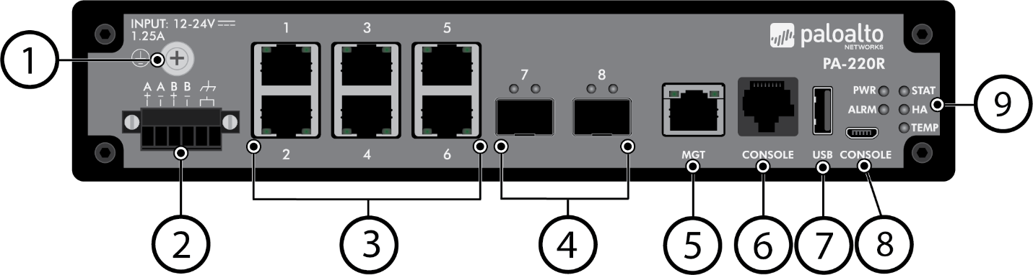
Layer 1 Setup:

- Find a Power Source to plug into your PA-220 Firewall and plug the firewall into the power supply with the power cord.
- Connect the console cable from the console port of the computer to the firewall console port.
- Connect the ethernet cable from the computer to the firewall’s management (MGT) port.
- Launch an internet browser and enter the IP address of the firewall in the URL field (https://ipaddress)
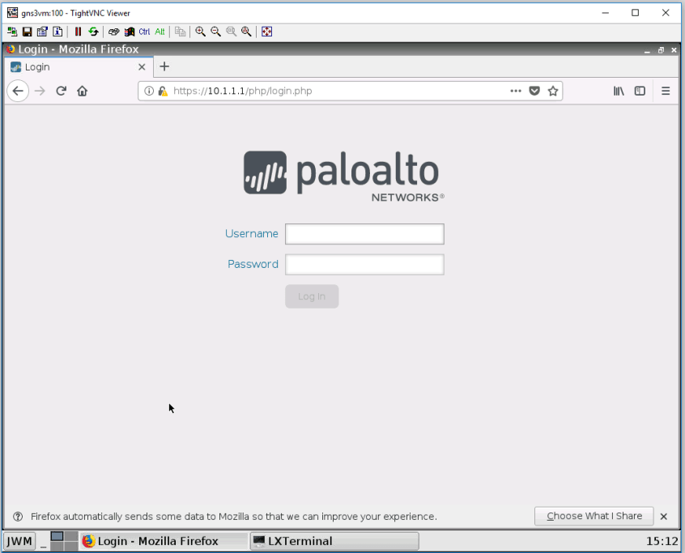
- You will be prompted to a Login Screen. The default username and password will be “admin”
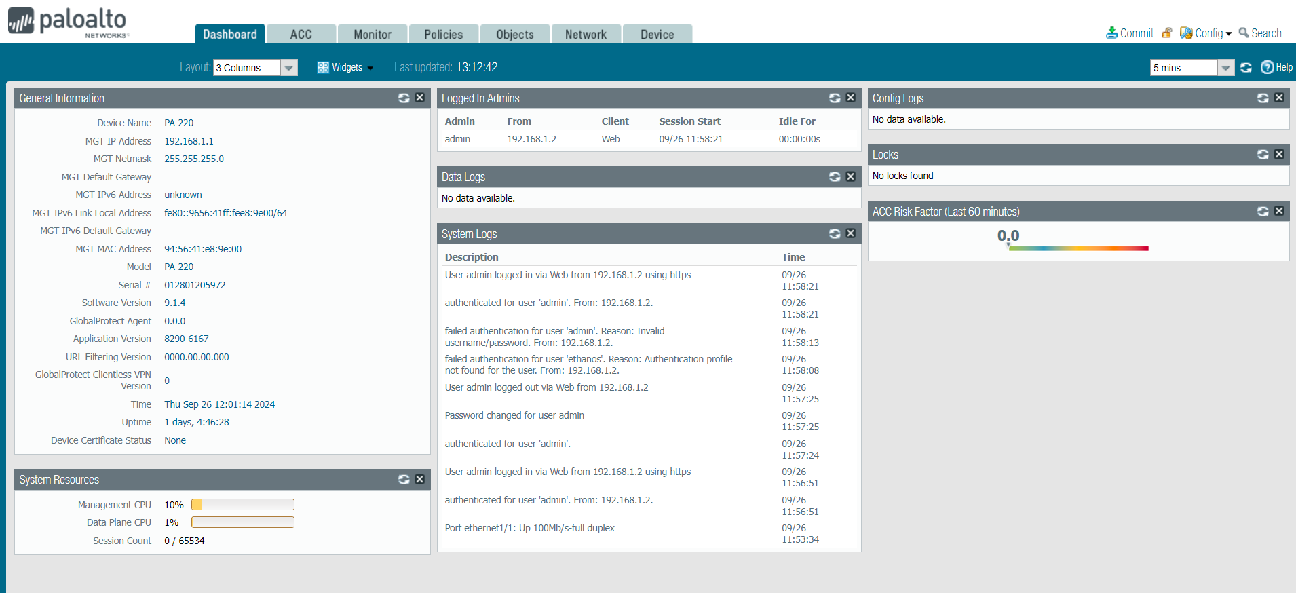
- Select the Network Tab at the top of the screen. Select zones and click the plus sign “add” to create a new security zone.

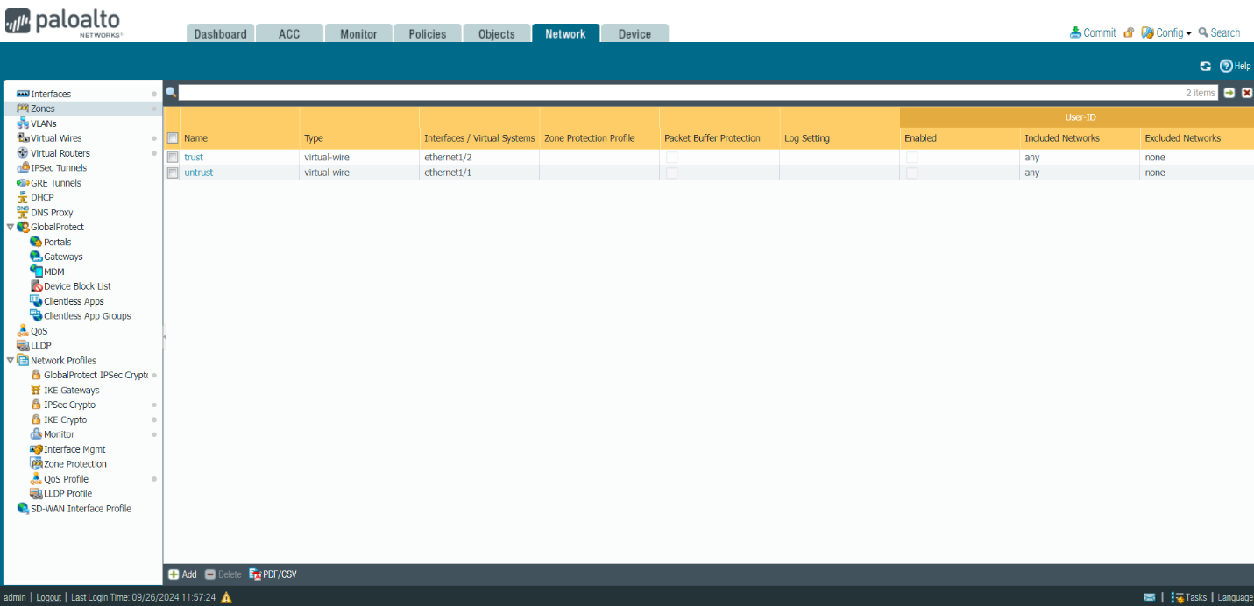

- Create security zone called Untrust-L3 and set it to Layer 3 type. Select “OK” to save the security zone.
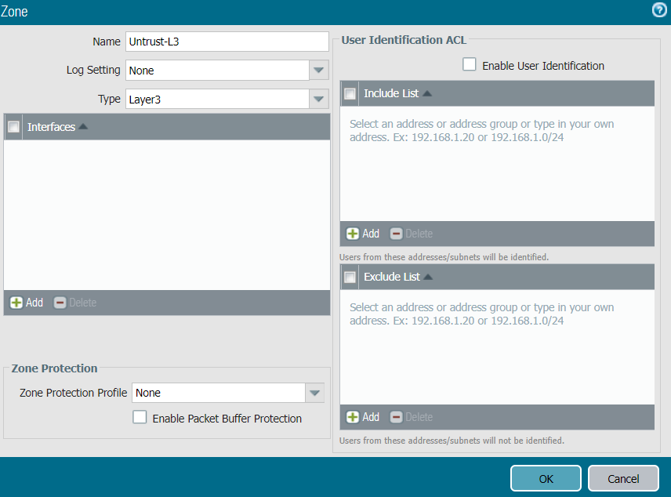

- Create security zone called Trust-L3 and set it to Layer 3 type. Select “OK” to save the security zone.
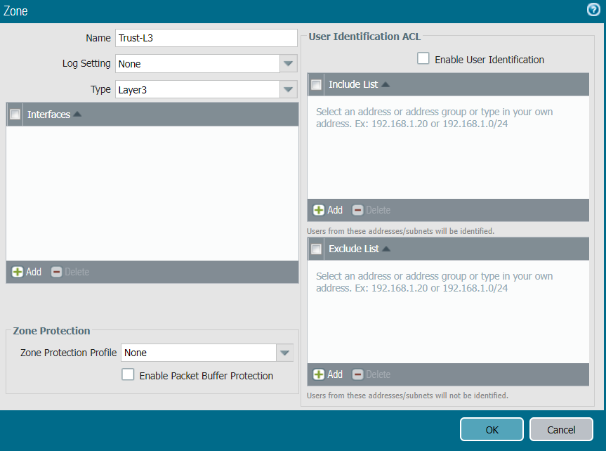

- Create security zone called Trust-L2 and set it to Layer 2 type. Select “OK” to save the security zone.
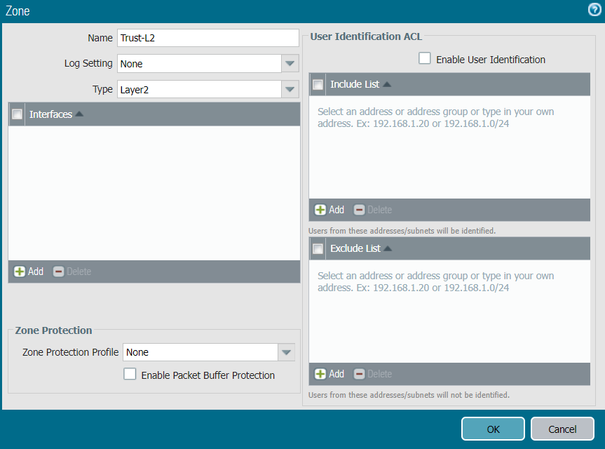

- This security zone page should come up once all the security zones are created.
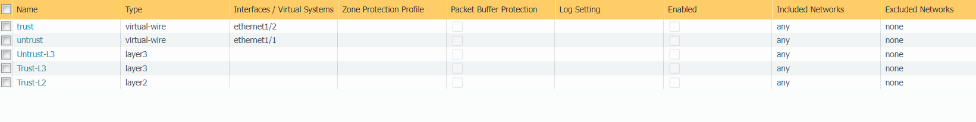
- Select interfaces in the network tab. At the bottom left page select “add aggregate group” to create a new network interface.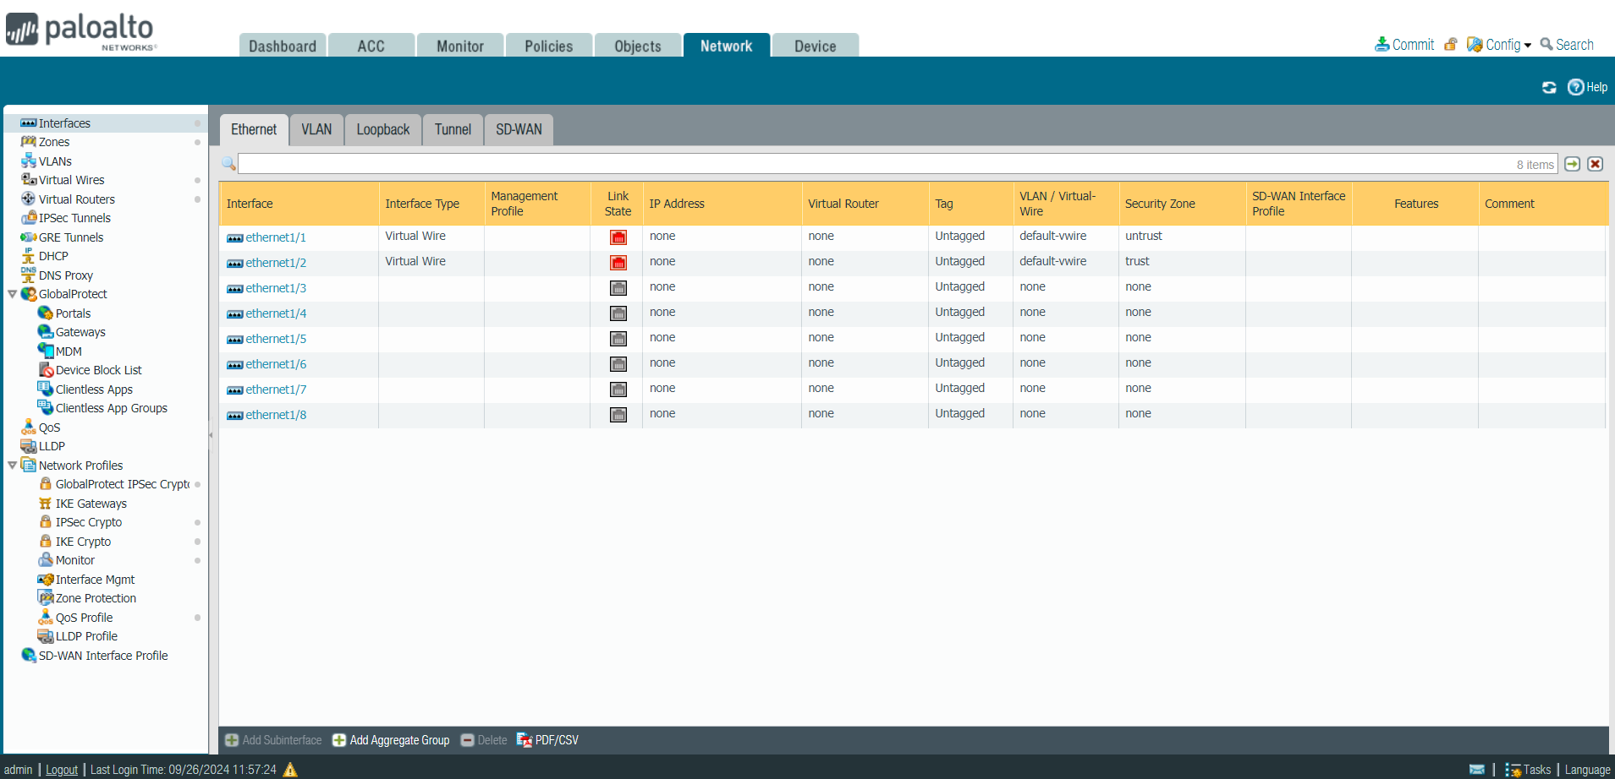
- Under the “Config” tab, configure ethernet 1/1 as a layer 3 interface. Assign it to the Untrust-L3 security zone. The virtual router settings should be set to default.
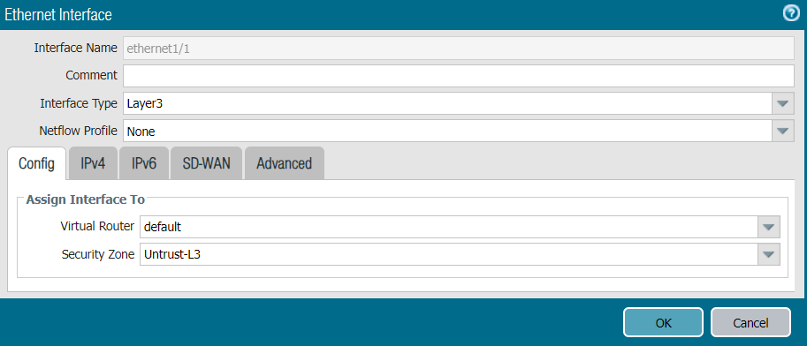
- Click on the IPv4 tab and select DHCP Client for the type. Select OK to save all settings for the ethernet1/1 network interface you just created.
- The network interfaces page will pop up. Your ethernet 1/1 settings should pop up as well.
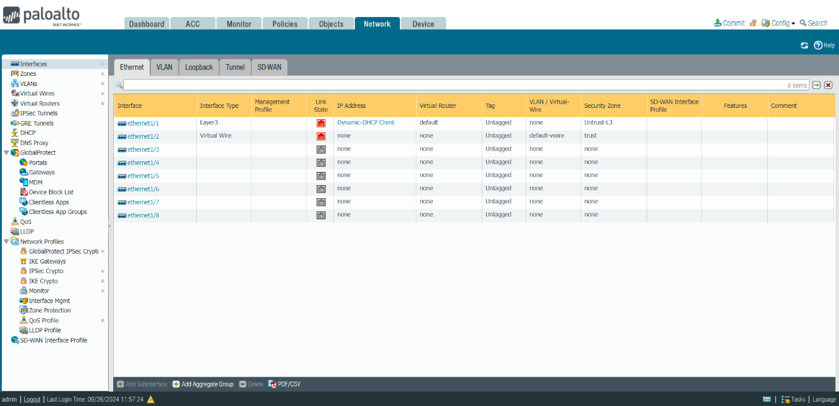

- In the Network tab, select the VLANs tab. At the bottom left corner of the page, select “add” to create a new VLAN.
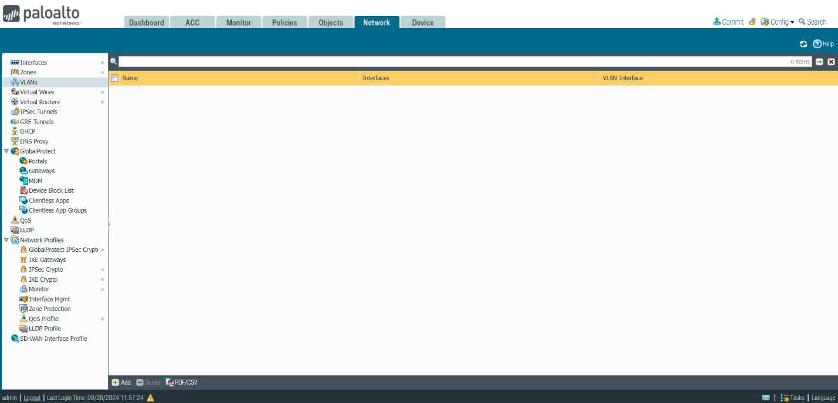

- In the vlan window, name it “Vlan Object” and select “vlan” as the VLAN interface. Click “OK” to save all settings.
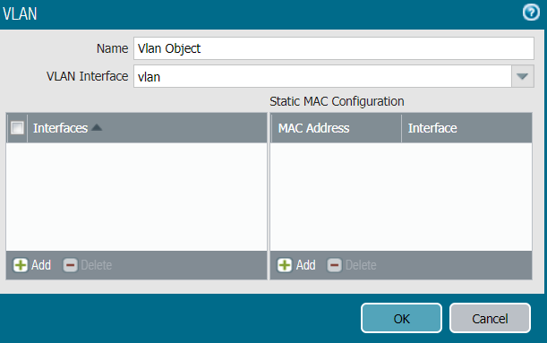

- Go to the ethernet interfaces tab. Add the rest of the ports to the VLAN we just created. For ports 1/2, 1/3, and 1/4, set their interface type to Layer2 and assign them to the VLAN object we just created.
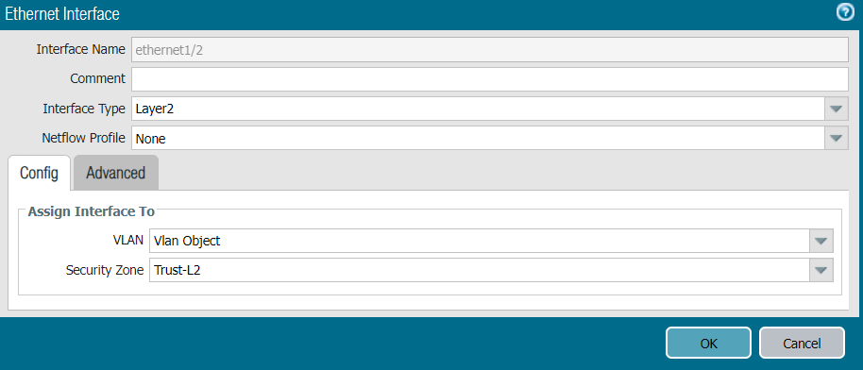
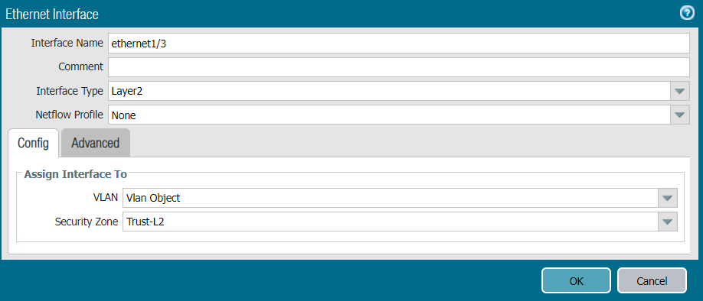
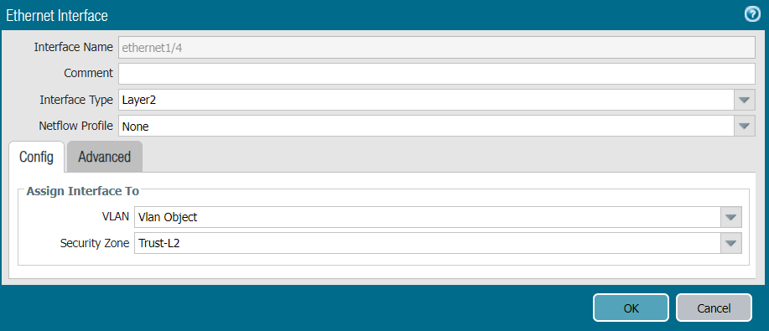

- In the Network tab, select the VLAN tab. Select the “vlan” interface.
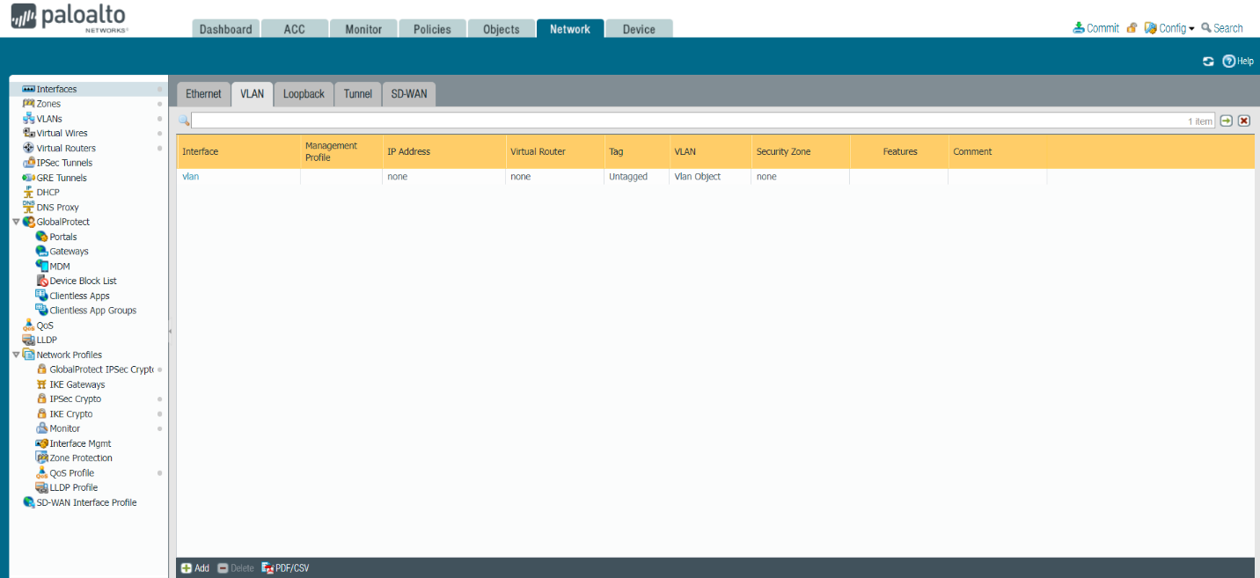

- Under the Config tab in the VLAN interface window, assign the interface to the created VLAN Vlan Object and set the security zone to Trust-L3.
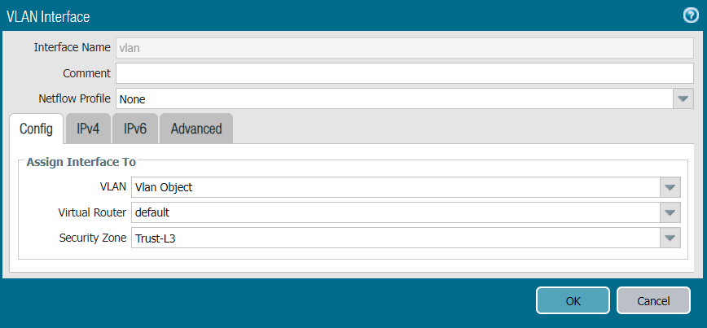

- Select the “IPv4” tab and enter a static IP address. Click “OK” to save all settings.
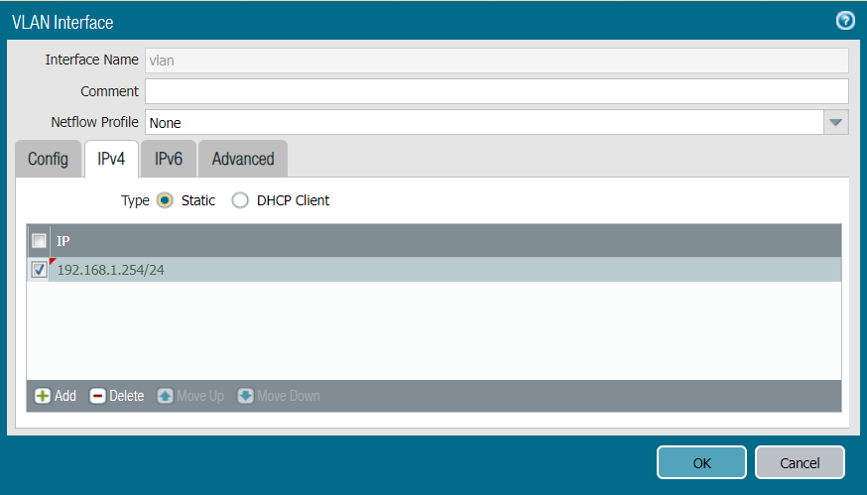

- In the Network tab, select DHCP. Select “Add” in the bottom right corner to create a new DHCP server.
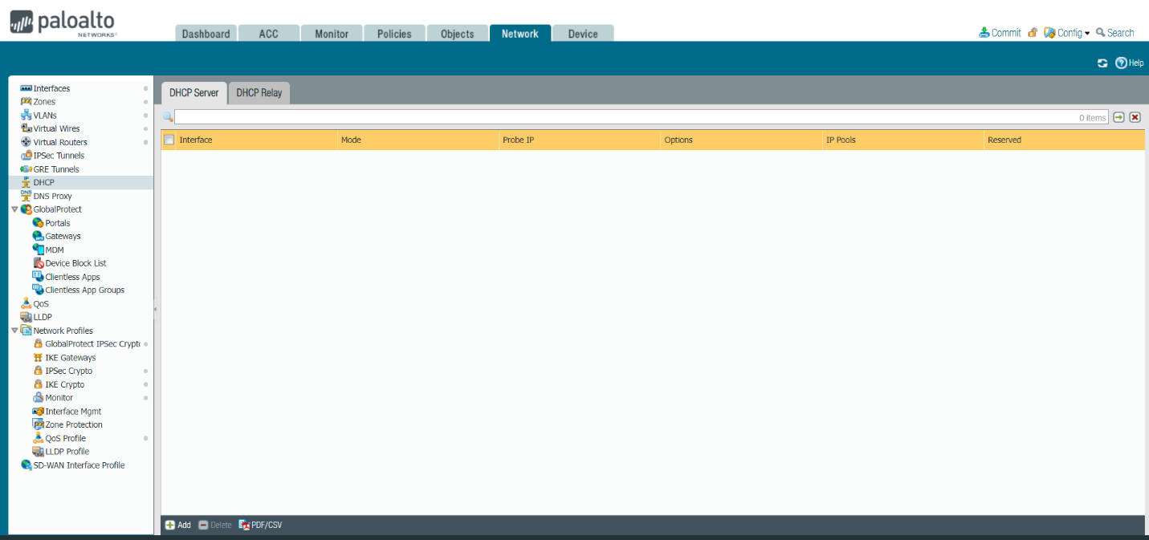
- In the DHCP Server window, assign the server to the created VLAN interface, set the lease as “Timeout” for an hour, and give it an appropriate IP address pool based on your network.
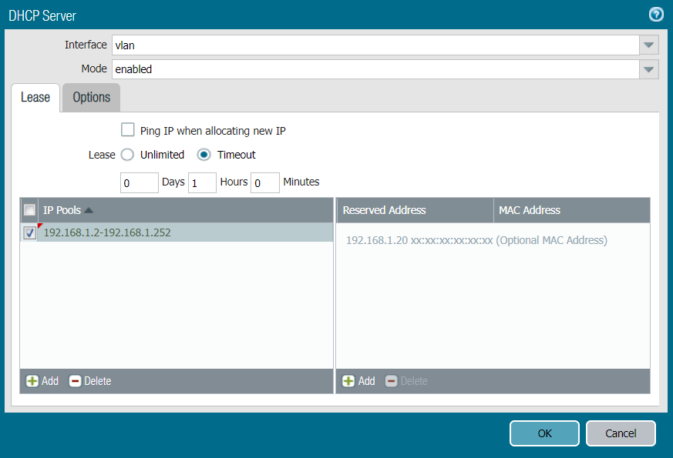

- Click on the “Options” tab, and select the inheritance port as ethernet 1/1. Set the gateway IP address, and subnet mask. Click “OK” to save all settings.
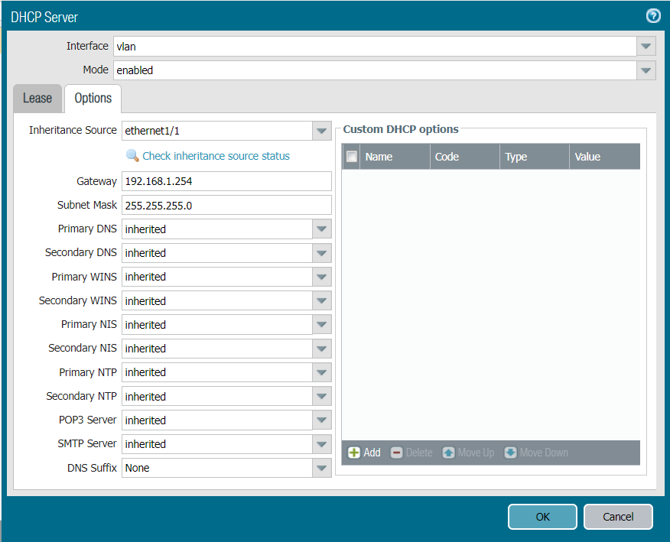

- Click on the Objects tab and then select Security Profile Groups. Click “Add” at the bottom left of the page to create a new security profile group.
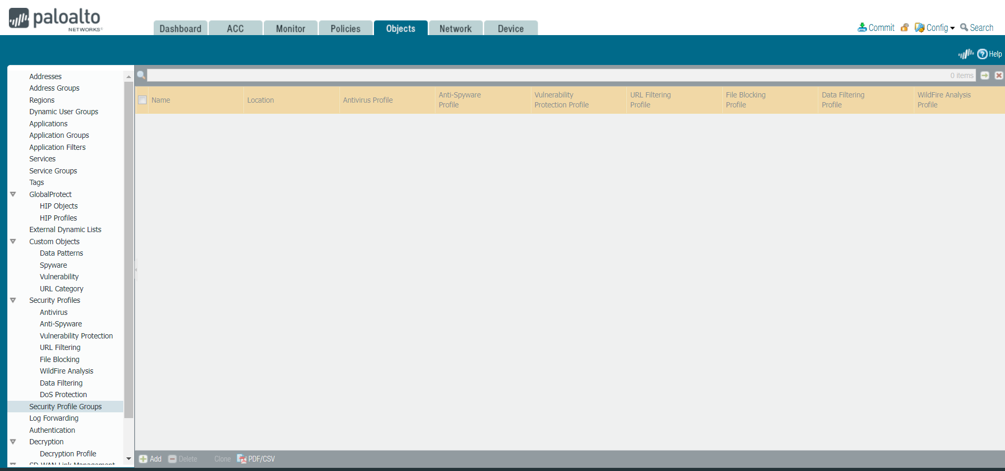

- In the Security Profile Group window, set the security profile group settings to the following. Click “OK” to save all settings.
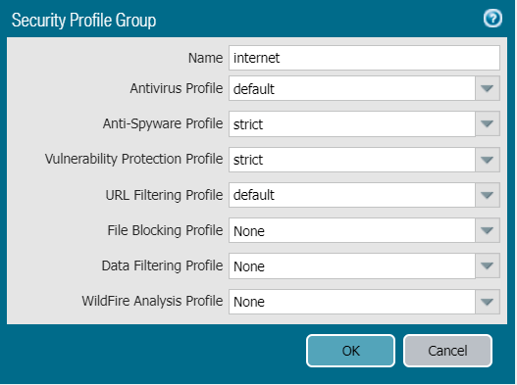

- Click on the “Security” tab and then click on the Security page. Click “Add” in the bottom left corner to create a new security policy.
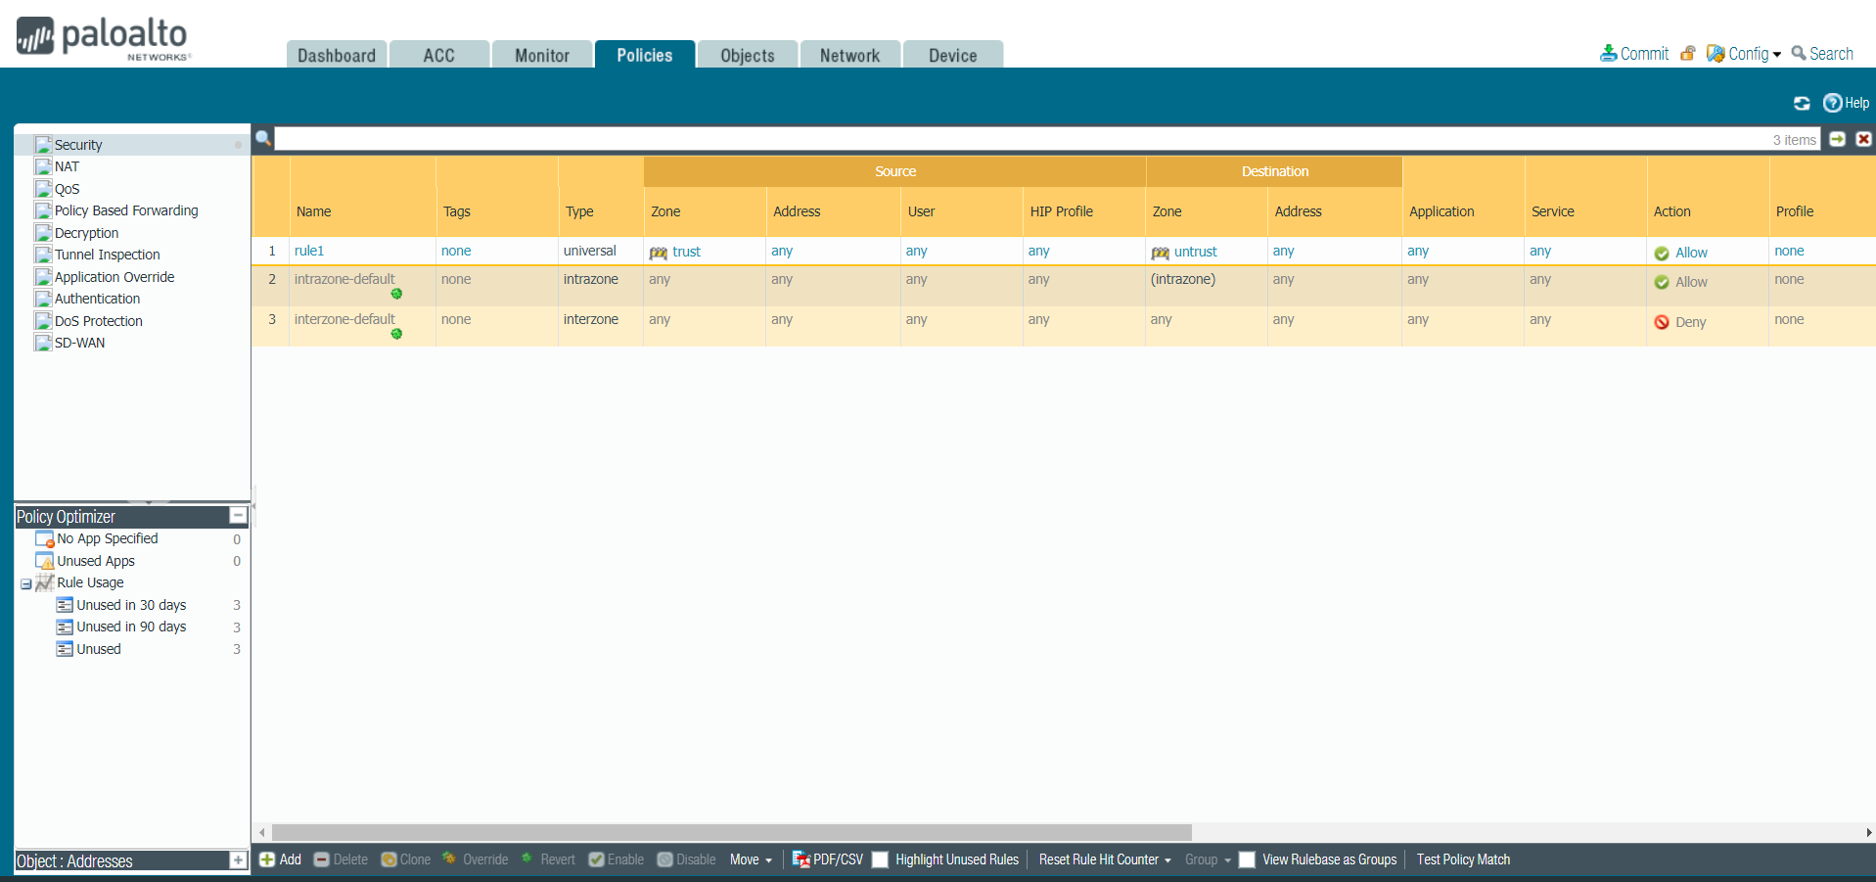

- In the Security Policy Rule window, in the General tab, give the security policy the name “Internet outgoing” and set the description as “all traffic to the internet”
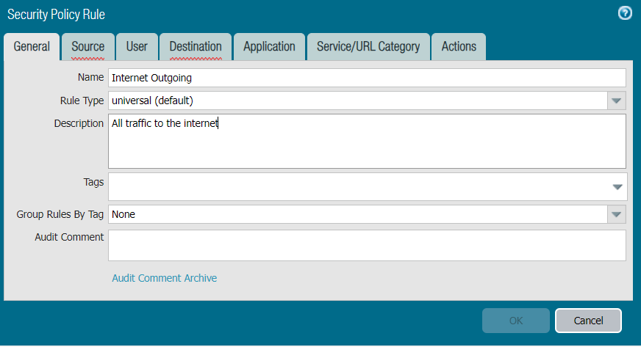

- Select the Source tab. Click “Add” to select a security zone and choose Trust-L3.
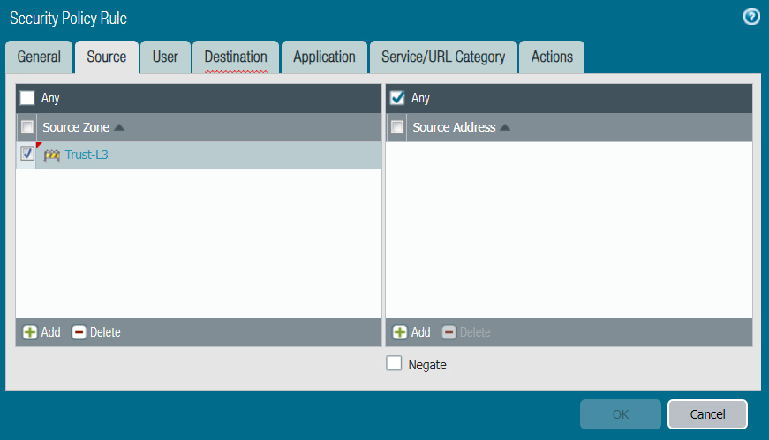

- In the Security Policy Rule window, select the Destination tab. Click “Add” to select a security zone, and choose Untrust-L3.
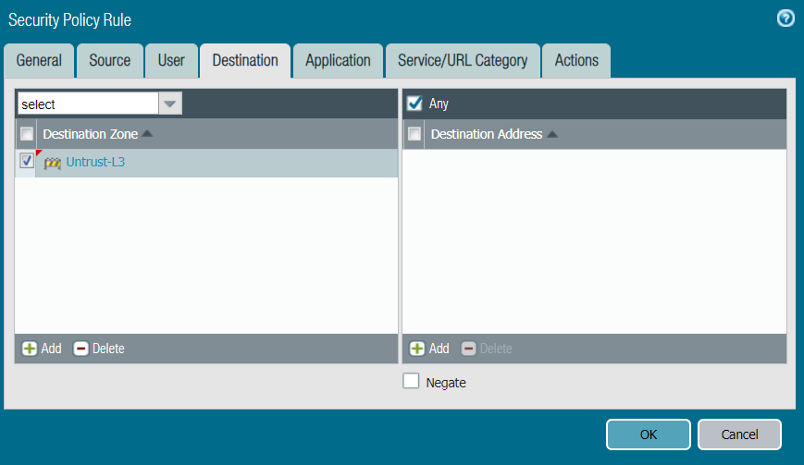

- Click the Actions tab. Set the action setting as “Allow”, the profile type as “Group”, and the group profile as “internet”. Select the “Log at Session End” checkmark. Click “OK” to implement the configured settings.
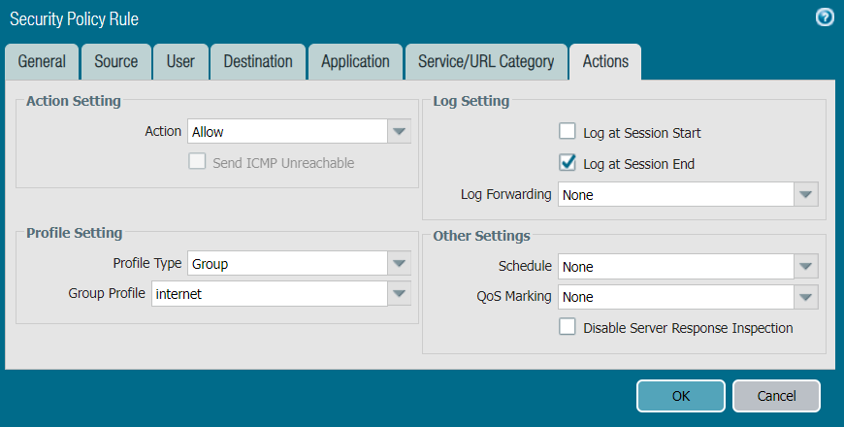

- In the Security Policies page you will see the security policy you created. Our new policy is Internet Outgoing on line 2.
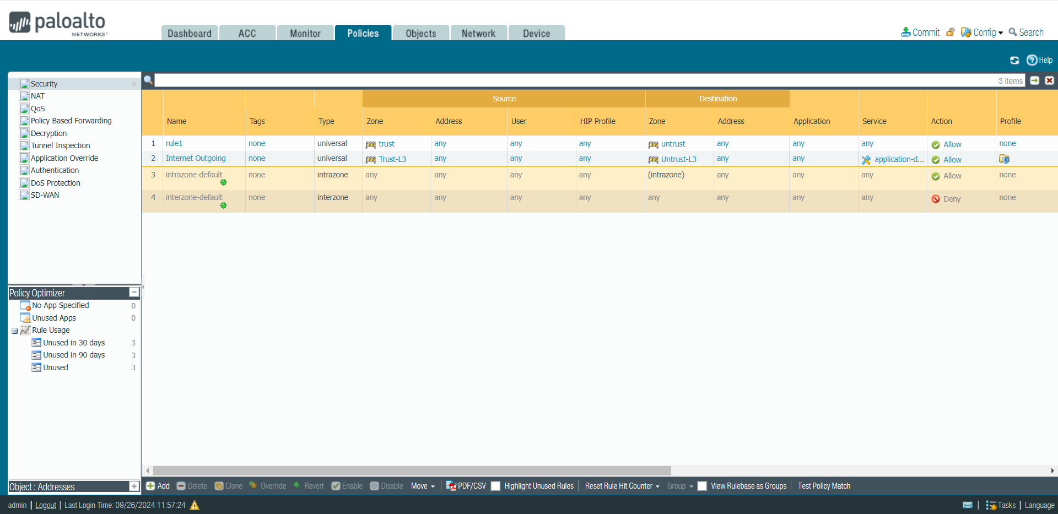

- In the Policies tab select NAT on the sidebar. Click “Add” in the bottom left corner to create a new NAT policy.
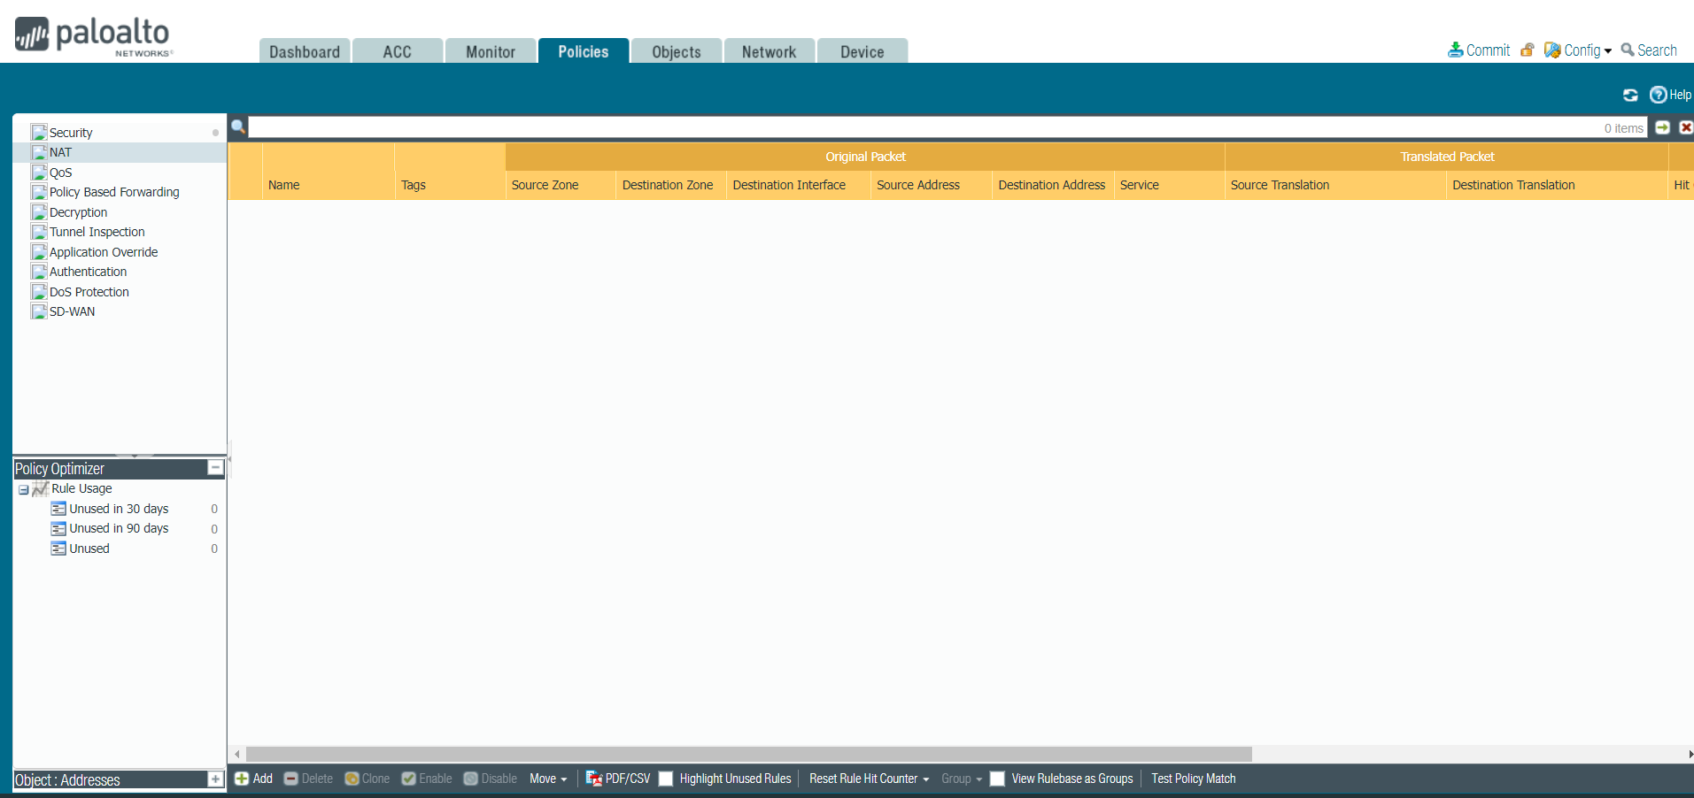

- Select the “Original Packet” tab. Click “Add” to add the Trust-L3 source zone. Set the destination zone as Untrust-L3 and the destination interface as port 1/1.
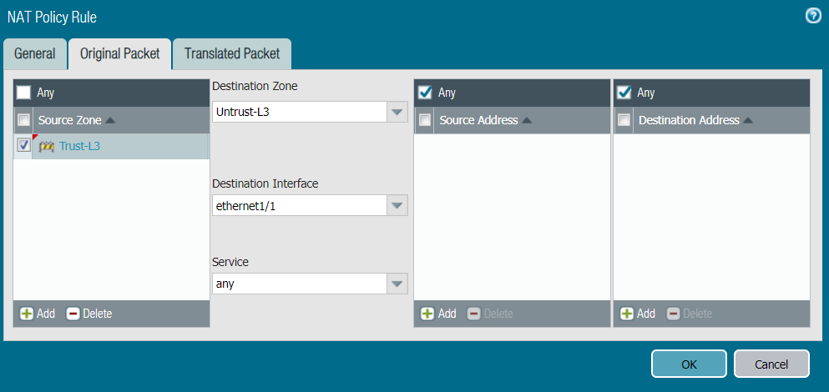

- Select the “Translated Packet” tab. Set the translation type as “Dynamic IP And Port” and set the source interface to be port 1/1. Click “OK” to save all settings.
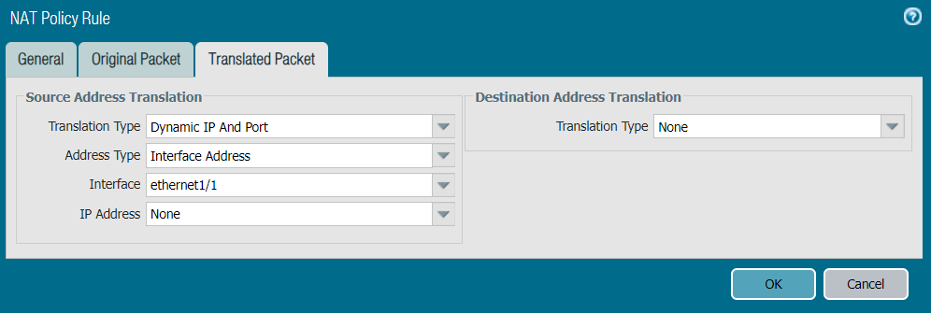

- The NAT policy we just created should appear on the NAT page.
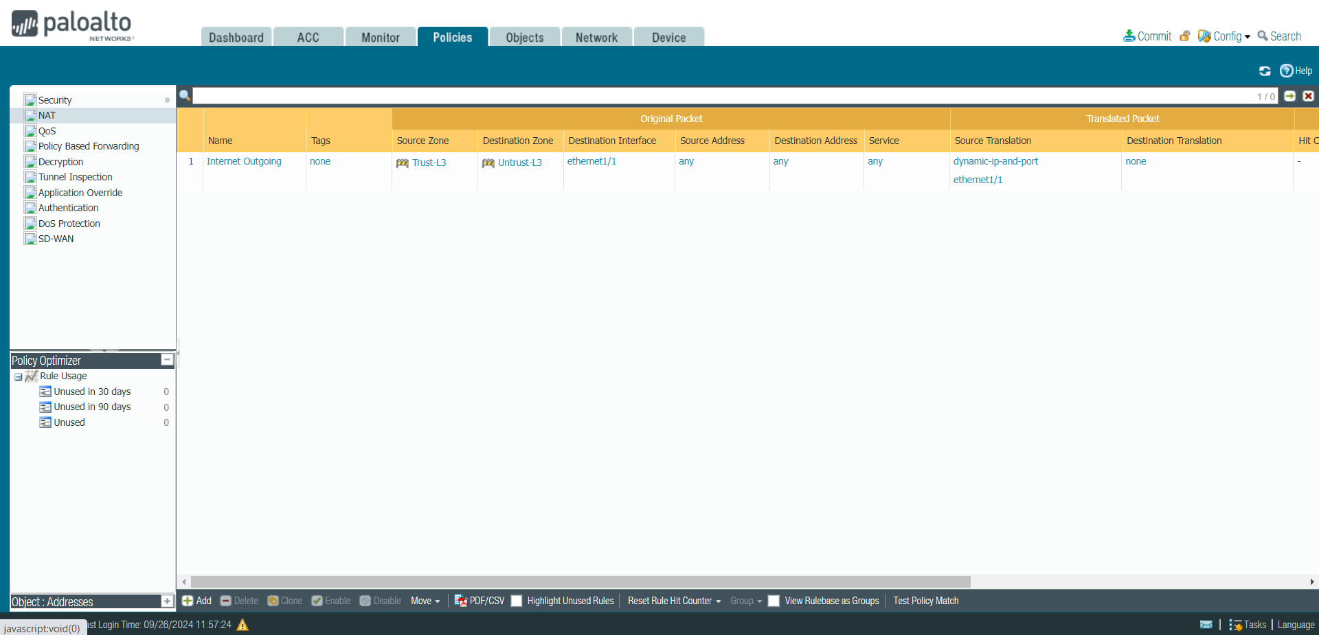
- Select the Device tab at the top of the page. Click “Setup” on the sidebar. Click on the “Interfaces” tab then click on the Management interface.
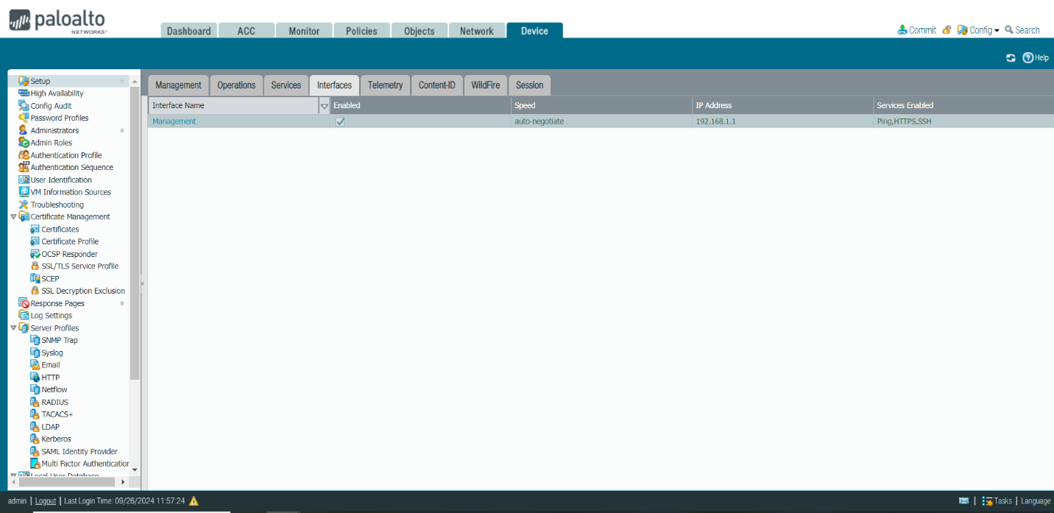

- In the firewall’s management interface settings, set the appropriate IP address, subnet mask, and default gateway. Click “OK” to save all settings.
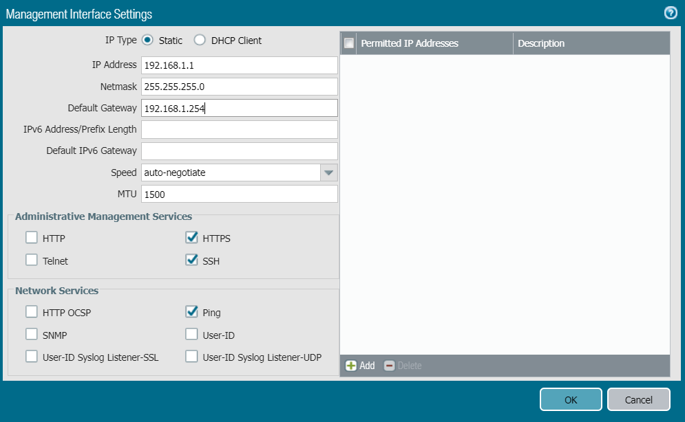

- Still on the Setup page, click on the “Services” tab. Click on the “Service Route Configuration” link.
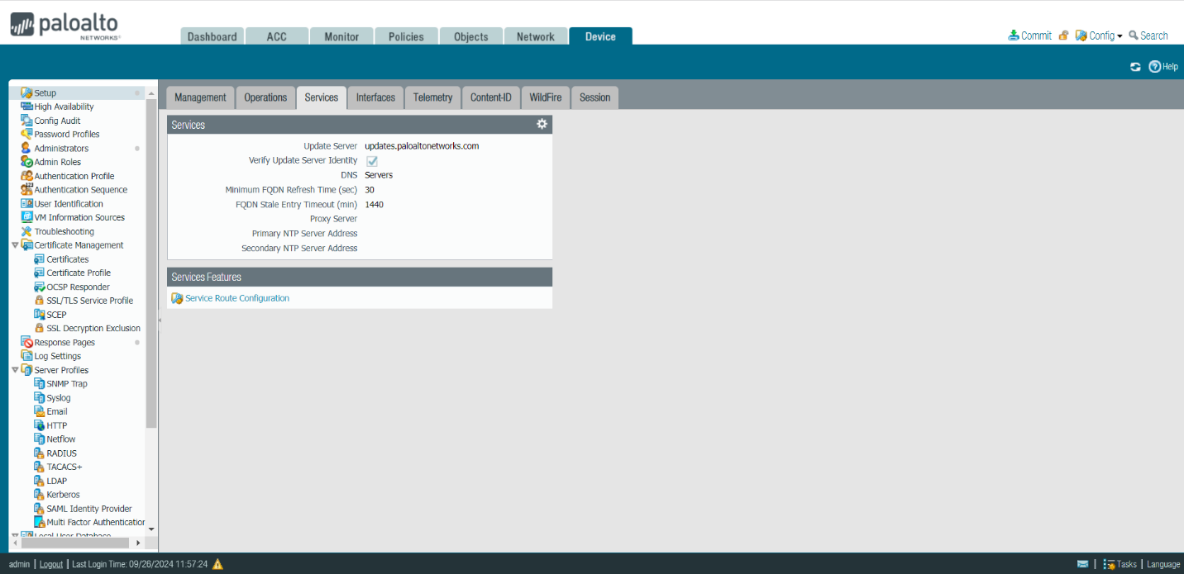

- Our primary DNS server is 8.8.8.8, and secondary DNS server is 8.8.4.4. Enter the appropriate IP addresses for the primary and secondary DNS servers. Click “OK” to save all settings.
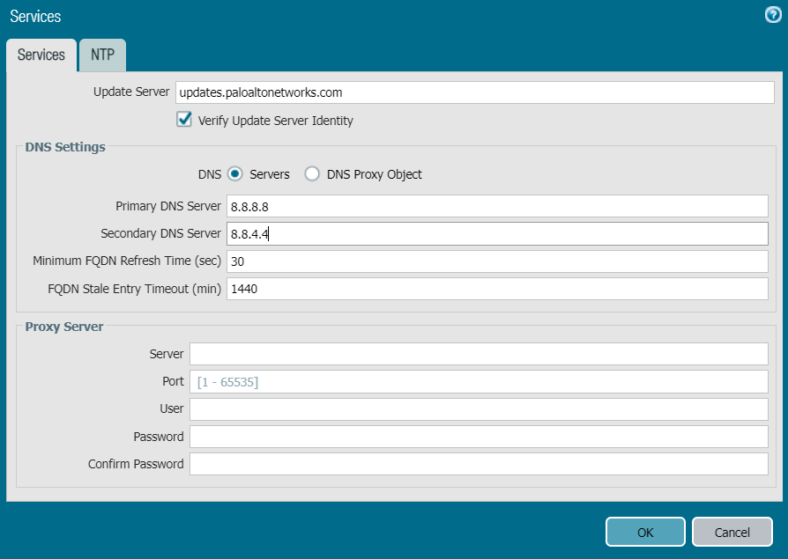

- The IP addresses of the DNS servers will show up on the Services tab.
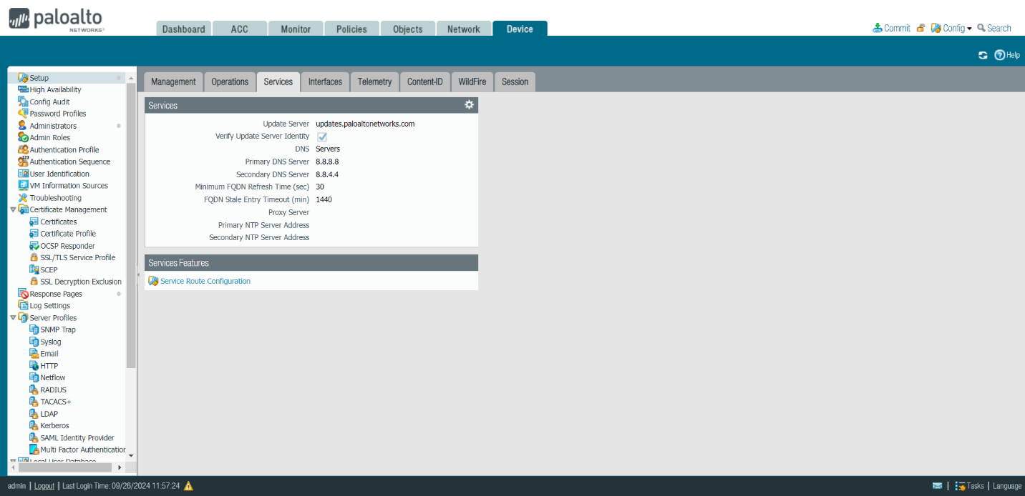

Problems:

Due to most of the lab being in the Graphical User Interface (GUI) of the PA-220 firewall, there was no command line configurations needed meaning the mistakes came from human error. The lab was straightforward as we were given a set procedure to follow, but we made a huge error at the beginning of the lab. When setting our SOHO network, we accidentally swapped the ports for the cables. We initially plugged in the configured port on our firewall to the router which created an infinite DHCP loop which flooded all devices in the CCNP internal class network with DHCP requests. We found first found out through one of our cybersecurity classmates looking around at other people’s ports to see why his workstation had crashed. We further confirmed that this problem was due to our layer 1 mistake when asking Mr. Mason for assistance and discovered the improperly connected cable and plugged the correct cable into the right port which fixed the problem.

Another problem came when we had made all the GUI configurations. When trying to commit our configurations to the firewall, the error message “virtual wire default-vwire is missing one or more interfaces.” Once we consulted other classmates, we found that they had experienced the same error previously and noticed that we left the default wire. To fix this problem we clicked back onto the Virtual Wires tab and deleted the wire from the listing. We then restarted our commit process and were able to successfully implement our configurations to the PA-220 Firewall.

Problems:
In this lab, we gained important skills through setting up our PA-220 firewall for a SOHO network. Learning these skills came through configuring security, NAT, DHCP, DNS, and more using the firewall’s GUI. We found asking our cybersecurity classmates to be super beneficial for our learning and their learning as well as they taught us certain concepts about the configuration process. We gained hands-on experience in setting up a PA-220 firewall in a SOHO network that we could apply in the future when wanting to set up small scale secure networks.

Sign Off:

